Video Ideas
rohit98.kumar@gmail.com Mihir Kavishwar Jun 5, 2024

Objectives
Playlist 1: Video Tour (Must have)
Playlist 2: Outdoor interviews (Must have)
Playlist 3: Zoom interviews (Nice to have)
Potential actors/interviewee
1. Can you tell us a bit about yourself and your current living situation?
2. Where do you currently live, and how did you find this place?
3. What were the most important factors for you when choosing your current housing?
4. Can you give us a quick tour of your place and highlight your favorite features?
5. What amenities does your housing provide that you find most useful?
6. Have you faced any challenges or issues with your current housing?
7. How do you manage living expenses, and do you think the cost is reasonable for what you get?
8. What is the neighborhood like around your housing?
9. How do you commute to campus, and how long does it usually take?
10. What advice would you give to new students looking for housing near the university?

Objectives
- Builds trust showing variety of people and variety of different locations (show our brand, show our faces)
- Gives information about a variety of different homes to educated students
- Someone on a early house hunt, can unintentionally get all the information about campus from our videos uneducated students
- Publicity → drive traffic to our website

Ideas

Mihir
- Zoom interviews which are more elaborate apart from the ideas below.

Rohit
- Interview students and ask them questions about where they lived + add a session where you give more info about the location of the place +1MK
- Campus tour of the apartment neighborhood +1MK

Playlist 1: Video Tour (Must have) Feb 28, 2025

Campus
- Proximity - A small map appears
- Landmarks (village, engineering buildings, leavey)
- Covering range - like 1 day just the frat row,
- Safety/ are we north side or west side of the campus?
- Lifestyle (taco bell, grocery)
- DPS range mention
- Highlight the campus dorms (help needed with a freshmen)
- Our experience - jokes, humour

Adam - Jefferson Block
- Proximity - A small map appears
- Landmarks (village, engineering buildings, leavey)
- Covering range - like 1 day just the frat row,
- Safety/ are we north side or west side of the campus?
- Lifestyle (taco bell, grocery)
- DPS range mention

Campus map and region breakdown
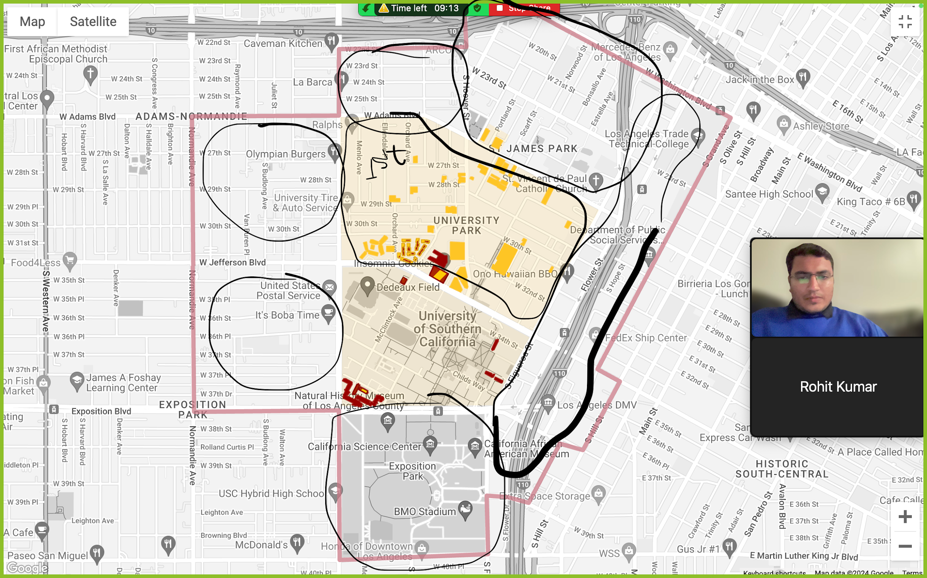

Parts of the campus

Block 1: Normandie - Jefferson

Block 2: Adams - Jefferson

Block 3: 23rd - Adams

Block 4: Figeroa & Flower

Playlist 2: Outdoor interviews (Must have) Nov 15, 2024

Questions (Relevant and entertaining)

Playlist 3: Zoom interviews (Nice to have) Dec 18, 2024

Potential actors/interviewee
Ray - for the tours
Monai’s friends - dorms
Random people for interviews (get from different communities)

1. Can you tell us a bit about yourself and your current living situation?
- What year are you in, and what are you studying?

2. Where do you currently live, and how did you find this place?
- Was it through a university resource, recommendation, or an online platform?

3. What were the most important factors for you when choosing your current housing?
- Price, location, amenities, roommates, etc.

4. Can you give us a quick tour of your place and highlight your favorite features?
- What do you love most about your current housing?

5. What amenities does your housing provide that you find most useful?
- Laundry facilities, parking, gym, study lounges, etc.

6. Have you faced any challenges or issues with your current housing?
- How did you resolve them?

7. How do you manage living expenses, and do you think the cost is reasonable for what you get?
- Any tips for budgeting or finding affordable options?

8. What is the neighborhood like around your housing?
- Are there any nearby grocery stores, cafes, or parks that you frequently visit?

9. How do you commute to campus, and how long does it usually take?
- Do you use public transportation, walk, bike, or drive?

10. What advice would you give to new students looking for housing near the university?
- Any dos and don’ts or things to look out for?

These questions will help students share their personal experiences, providing valuable insights and practical tips for others looking for housing near the university.

